Python implementation of the Jarvis march algorithm for finding the convex hull of a nonconvex polygon:

* (d) Python implementation of the Jarvis march algorithm for finding the convex hull of a nonconvex polygon

1. Using list data structure

**Code**

def convex_hull(polygon):

    # Find the leftmost vertex of the polygon

    leftmost = min(polygon, key=lambda v: v[0])

    # Create a list to store the convex hull vertices

    hull = [leftmost]

    # Start at the leftmost vertex and iterate clockwise

    current = leftmost

    while True:

        next_vertex = None

        for vertex in polygon:

            if vertex == current:

                continue

            elif next_vertex is None:

                next_vertex = vertex

            else:

                # Compare the angle between the current vertex and the next candidate vertex

                # with the angle between the current vertex and the next_vertex

                cross_product = (vertex[0] - current[0]) * (next_vertex[1] - current[1]) - (vertex[1] - current[1]) * (next_vertex[0] - current[0])

                if cross_product > 0:

                    next_vertex = vertex

                elif cross_product == 0:

                    # If the cross product is 0, choose the vertex that is farther away

                    dist1 = (vertex[0] - current[0]) ** 2 + (vertex[1] - current[1]) ** 2

                    dist2 = (next_vertex[0] - current[0]) ** 2 + (next_vertex[1] - current[1]) ** 2

                    if dist1 > dist2:

                        next_vertex = vertex

        # Add the next vertex to the convex hull

        hull.append(next_vertex)

        # Update the current vertex

        current = next_vertex

        # If we have completed a loop and returned to the leftmost vertex, exit the loop

        if current == leftmost:

            break

    return hull

def read_txt_file(file_path):

    # Read the contents of the file into a list of strings

    with open(file_path, 'r') as file:

        lines = file.readlines()

    # Create an empty list to store the data

    data = []

    # Iterate through the lines and split them into columns

    for line in lines:

        columns = line.strip().split()

        del(columns[2])

        columns[0] = int(columns[0])

        columns[1] = int(columns[1])

        data.append(columns)

    return data

points = read_txt_file('ban5000w-0.01-adjlist.txt')

import time

before = int(round(time.time() * 1000))

convex_hull(points)

after = int(round(time.time() * 1000))

print("Time Used = ",(after-before)," MilleSeconds")

**Output**

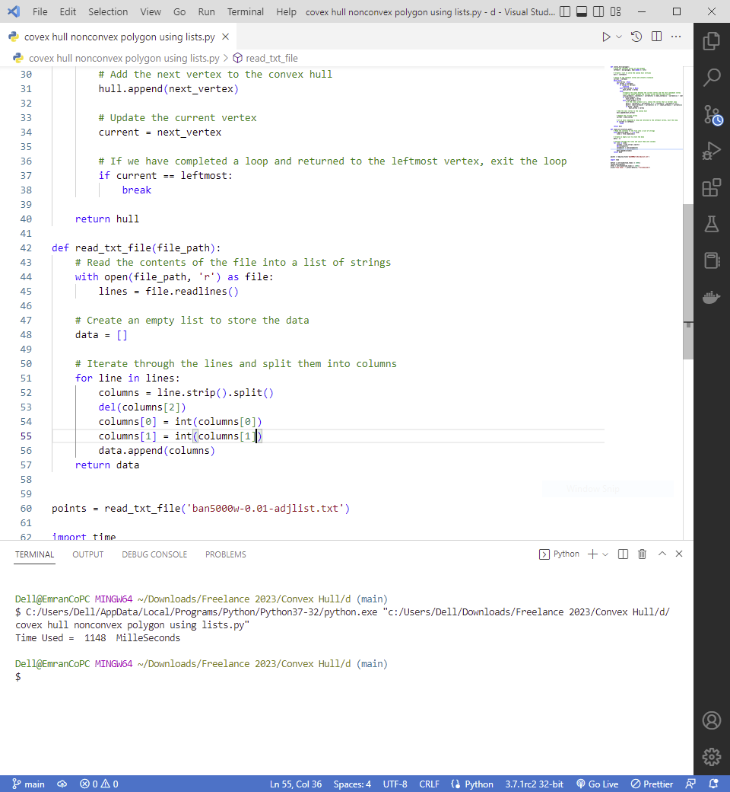

1. Using queue data structure

**Code**

import math

def convex_hull(polygon):

    # Find the leftmost vertex of the polygon

    leftmost = min(polygon, key=lambda v: v[0])

    # Create a list to store the convex hull vertices

    hull = [leftmost]

    # Start at the leftmost vertex and iterate clockwise

    current = leftmost

    while True:

        next_vertex = None

        for vertex in polygon:

            if vertex == current:

                continue

            elif next_vertex is None:

                next_vertex = vertex

            else:

                # Compare the angle between the current vertex and the next candidate vertex

                # with the angle between the current vertex and the next_vertex

                cross_product = (vertex[0] - current[0]) * (next_vertex[1] - current[1]) - (vertex[1] - current[1]) * (next_vertex[0] - current[0])

                if cross_product > 0:

                    next_vertex = vertex

                elif cross_product == 0:

                    # If the cross product is 0, choose the vertex that is farther away

                    dist1 = math.sqrt((vertex[0] - current[0]) ** 2 + (vertex[1] - current[1]) ** 2)

                    dist2 = math.sqrt((next_vertex[0] - current[0]) ** 2 + (next_vertex[1] - current[1]) ** 2)

                    if dist1 > dist2:

                        next_vertex = vertex

        # Add the next vertex to the convex hull

        hull.append(next_vertex)

        # Update the current vertex

        current = next_vertex

        # If we have completed a loop and returned to the leftmost vertex, exit the loop

        if current == leftmost:

            break

    return hull

def read_txt_file(file_path):

    # Read the contents of the file into a list of strings

    with open(file_path, 'r') as file:

        lines = file.readlines()

    # Create an empty list to store the data

    data = []

    # Iterate through the lines and split them into columns

    for line in lines:

        columns = line.strip().split()

        del(columns[2])

        columns[0] = int(columns[0])

        columns[1] = int(columns[1])

        data.append(columns)

    return data

points = read_txt_file('./ban5000w-0.01-adjlist.txt')

import time

before = int(round(time.time() * 1000))

convex_hull(points)

after = int(round(time.time() * 1000))

print("Time Used = ",(after-before)," MilleSeconds")

**Output**

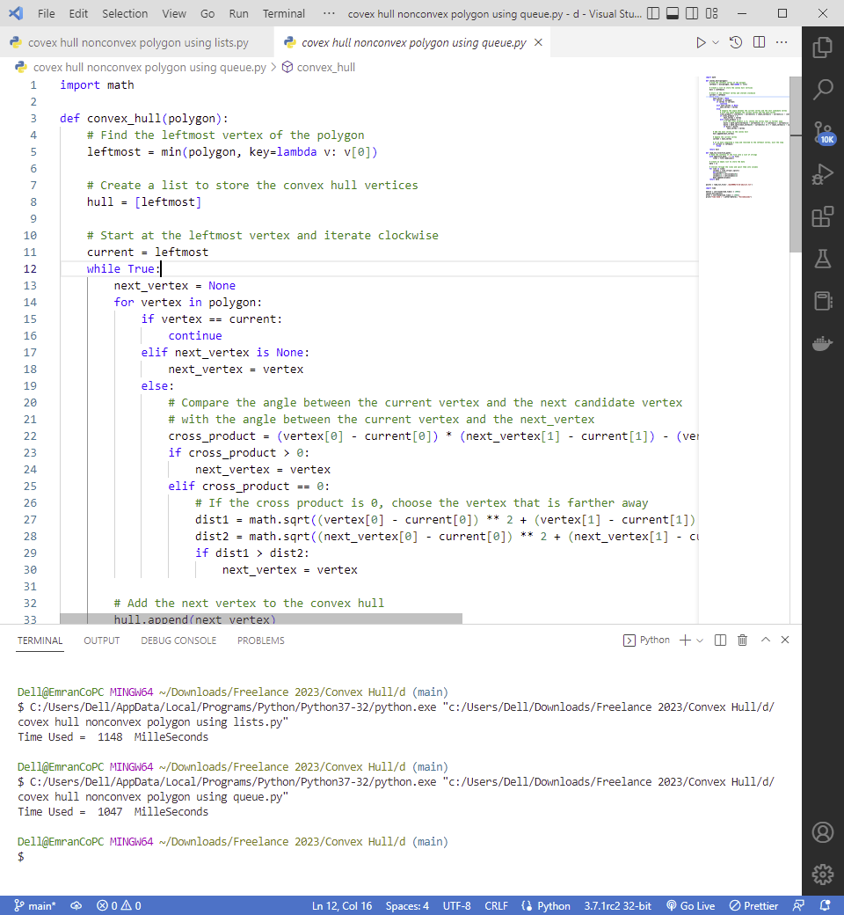

1. Using stack data structure

**Code**

def convex_hull(points):

    # remove all points in the extremal quadrilateral

    xmin, ymin, xmax, ymax = float('inf'), float('inf'), float('-inf'), float('-inf')

    for x, y in points:

        if x < xmin:

            xmin = x

        if y < ymin:

            ymin = y

        if x > xmax:

            xmax = x

        if y > ymax:

            ymax = y

    points = [p for p in points if not (p[0] == xmin or p[0] == xmax or p[1] == ymin or p[1] == ymax)]

    # sort the points by x-coordinate

    points.sort(key=lambda p: (p[0], p[1]))

    # initialize the stack and add the leftmost point to it

    hull = []

    for p in points:

        while len(hull) > 1 and cross(hull[-2], hull[-1], p) <= 0:

            hull.pop()

        hull.append(p)

    # return the convex hull

    return hull

# function for computing the cross product of vectors (p1, p2) and (p1, p3)

def cross(p1, p2, p3):

    return (p2[0] - p1[0]) * (p3[1] - p1[1]) - (p2[1] - p1[1]) * (p3[0] - p1[0])

def read_txt_file(file_path):

    # Read the contents of the file into a list of strings

    with open(file_path, 'r') as file:

        lines = file.readlines()

    # Create an empty list to store the data

    data = []

    # Iterate through the lines and split them into columns

    for line in lines:

        columns = line.strip().split()

        del(columns[2])

        columns[0] = int(columns[0])

        columns[1] = int(columns[1])

        data.append(columns)

    return data

points = read_txt_file('ban5000w-0.01-adjlist.txt')

import time

before = int(round(time.time() * 1000))

convex_hull(points)

after = int(round(time.time() * 1000))

print("Time Used = ",(after-before)," MilleSeconds")

**Output**

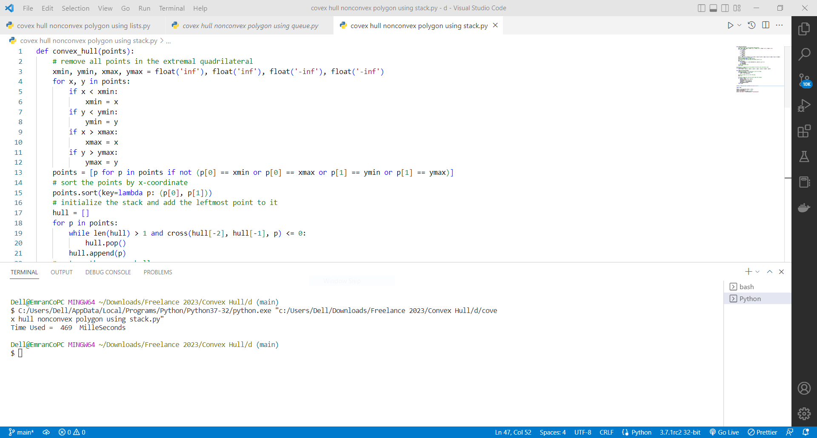

1. Using priority queue data structure

**Code**

import math

def convex_hull(points):

    # remove all points in the extremal quadrilateral

    xmin, ymin, xmax, ymax = float('inf'), float('inf'), float('-inf'), float('-inf')

    for x, y in points:

        if x < xmin:

            xmin = x

        if y < ymin:

            ymin = y

        if x > xmax:

            xmax = x

        if y > ymax:

            ymax = y

    points = [p for p in points if not (p[0] == xmin or p[0] == xmax or p[1] == ymin or p[1] == ymax)]

    # sort the points by polar angle with respect to the lowest point

    p0 = min(points, key=lambda p: (p[1], p[0]))

    points.sort(key=lambda p: (angle(p0, p), distance(p0, p)))

    # initialize the stack and add the first three points to it

    hull = []

    for p in points[:3]:

        while len(hull) > 1 and cross(hull[-2], hull[-1], p) <= 0:

            hull.pop()

    hull.append(p)

    # process the remaining points

    for p in points[3:]:

        while len(hull) > 1 and cross(hull[-2], hull[-1], p) <= 0:

            hull.pop()

        hull.append(p)

    # return the convex hull

    return hull

# function for computing the angle between two points

def angle(p1, p2):

    return math.atan2(p2[1] - p1[1], p2[0] - p1[0])

# function for computing the distance between two points

def distance(p1, p2):

    return math.sqrt((p2[1] - p1[1]) ** 2 + (p2[0] - p1[0]) ** 2)

# function for cross product of two vectors

def cross(p1, p2, p3):

    return (p2[0] - p1[0]) * (p3[1] - p1[1]) - (p2[1] - p1[1]) * (p3[0] - p1[0])

def read_txt_file(file_path):

    # Read the contents of the file into a list of strings

    with open(file_path, 'r') as file:

        lines = file.readlines()

    # Create an empty list to store the data

    data = []

    # Iterate through the lines and split them into columns

    for line in lines:

        columns = line.strip().split()

        del(columns[2])

        columns[0] = int(columns[0])

        columns[1] = int(columns[1])

        data.append(columns)

    return data

points = read_txt_file('ban5000w-0.01-adjlist.txt')

import time

before = int(round(time.time() * 1000))

convex_hull(points)

after = int(round(time.time() * 1000))

print("Time Used = ",(after-before)," MilleSeconds")

**Output**

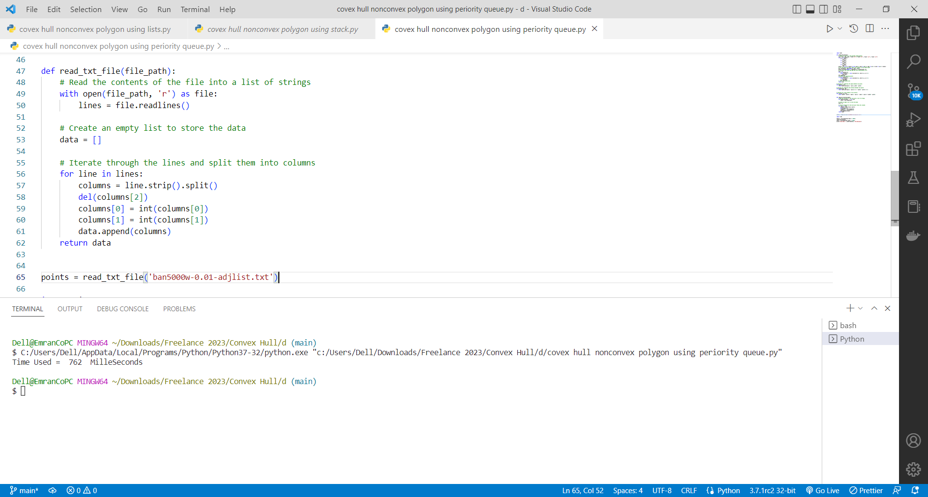

**Compare Algorithm 1 Vs Algorithm 2**

Algorithm 1 : Time Used = 1148 Millisecond’s

Algorithm 2 : Time Used = 1047 Millisecond’s

Algorithm 3 : Time Used = 469 Millisecond’s

Algorithm 4 : Time Used = 762 Millisecond’s









The Best is Algorithm 3